31. Write a LEX program to identify and count positive and negative numbers.

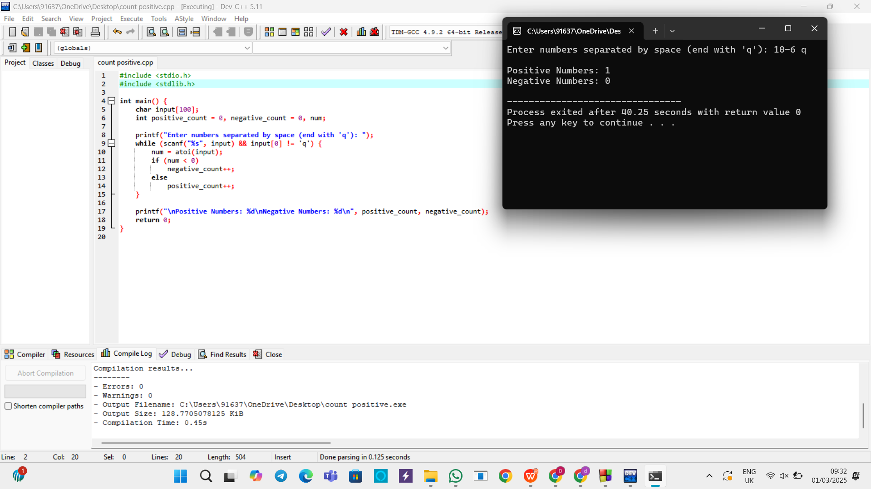

32. A networking company wants to validate the URL for their clients. Write a LEX

program to implement the same.

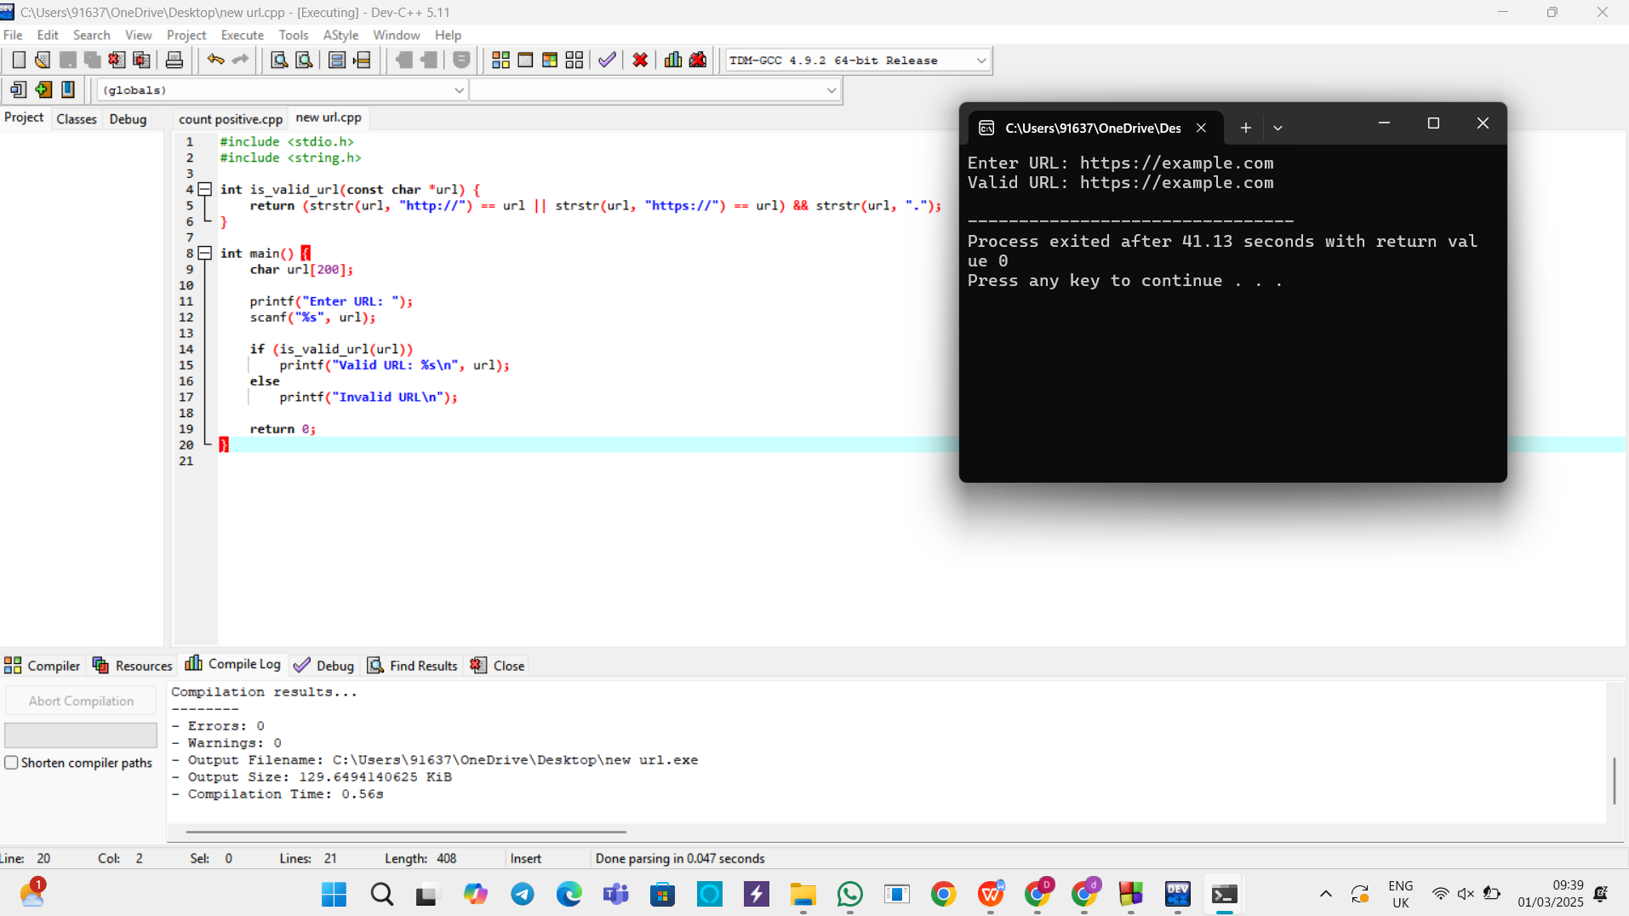

33. School management wants to validate DOB of all students. Write a LEX program to

implement it.

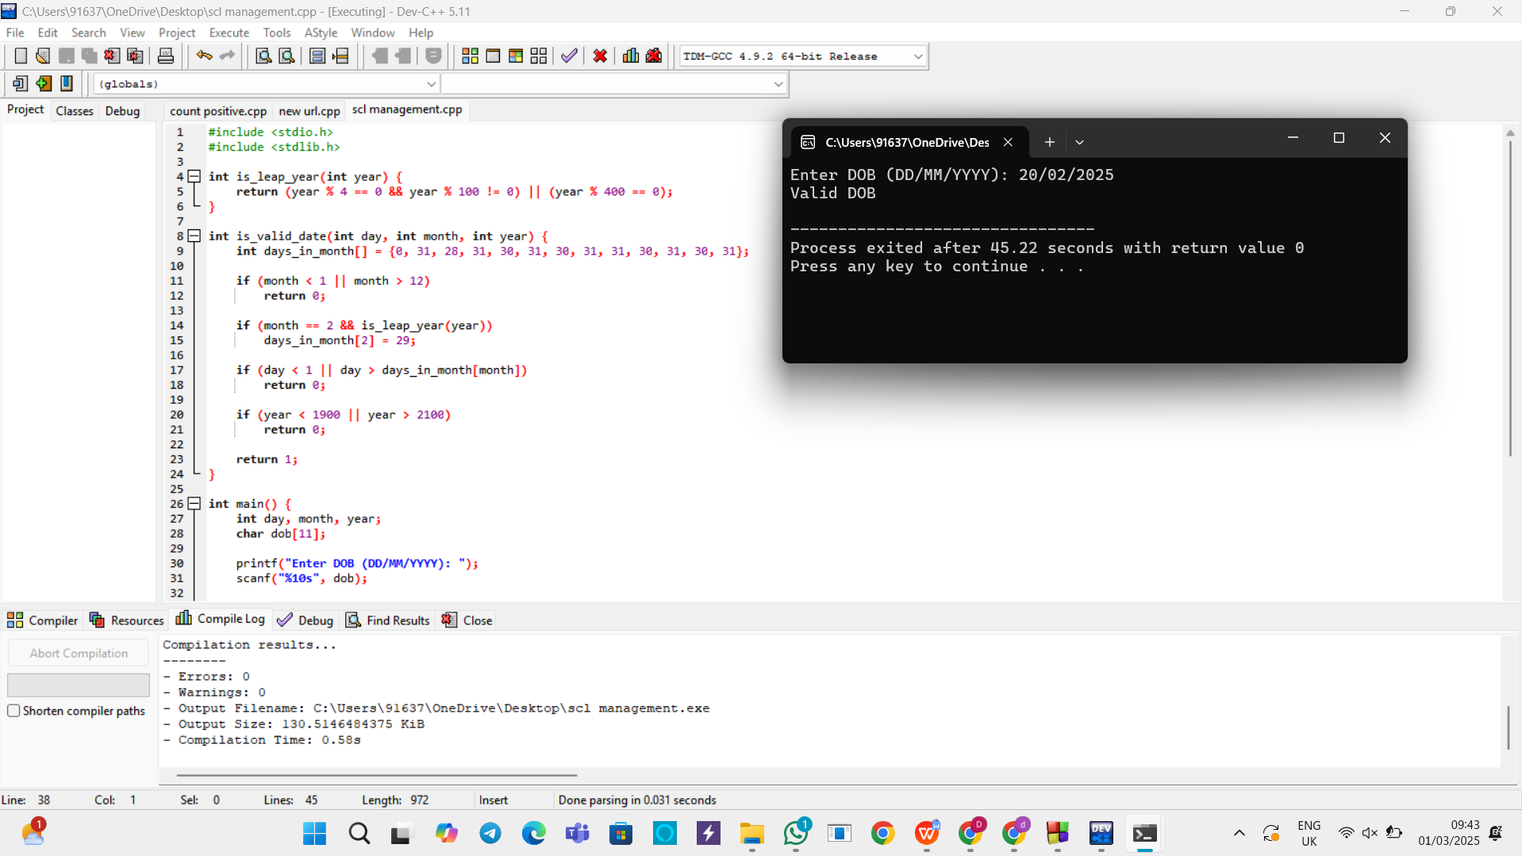

1. Write a LEX program to check whether the given input is digit or not.

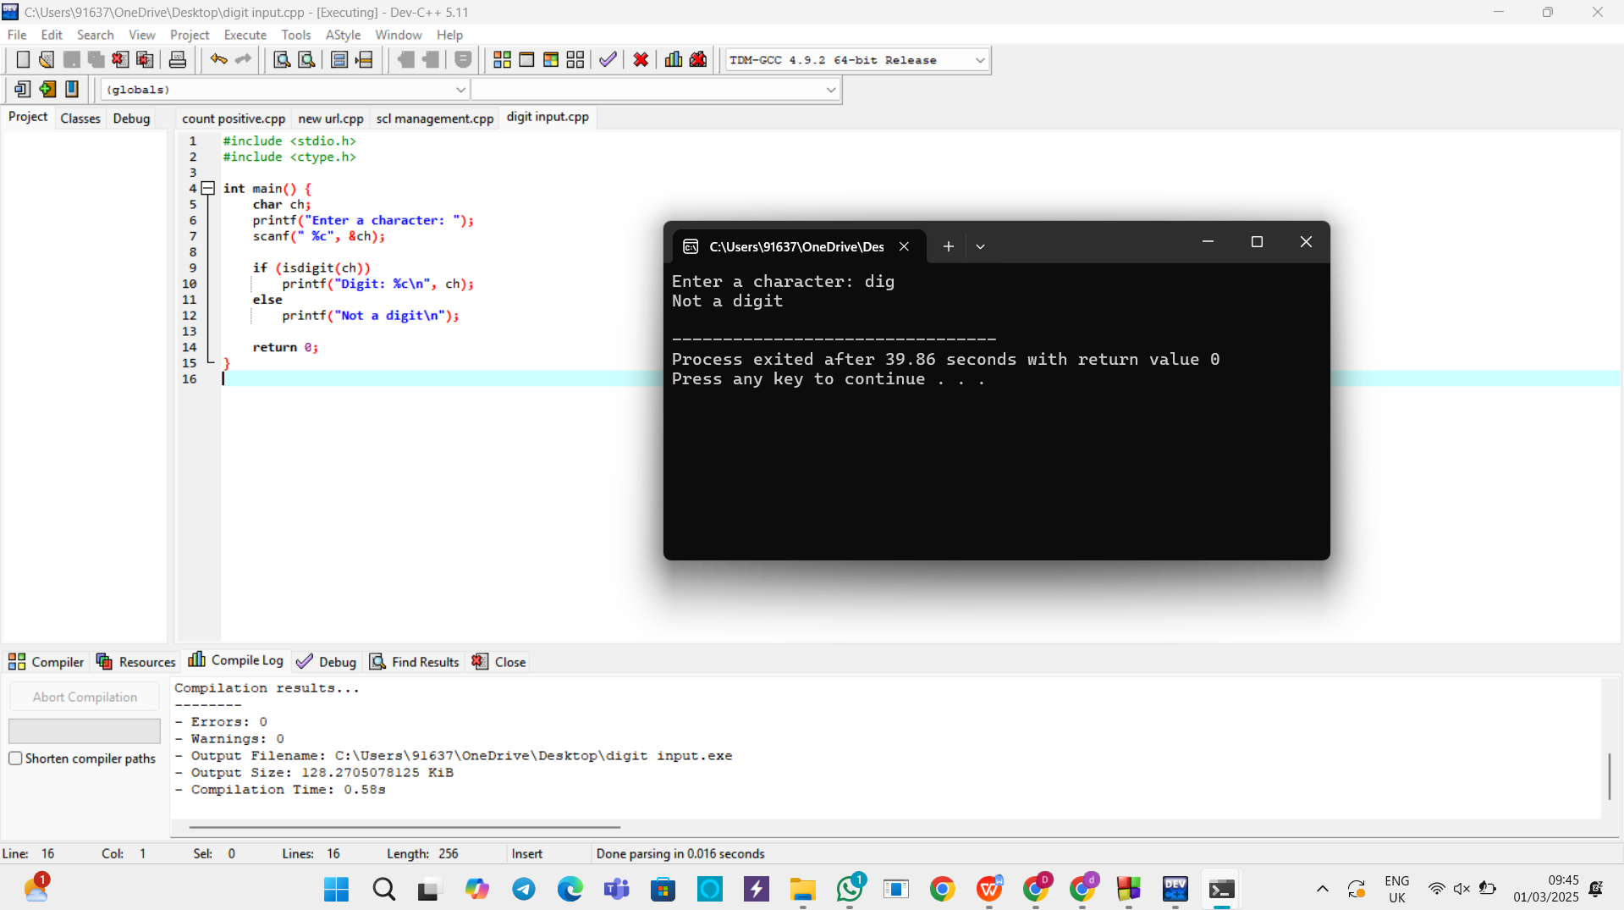

35. A School student was asked to do basic mathematical operations. Implement a LEX

program to implement the same.

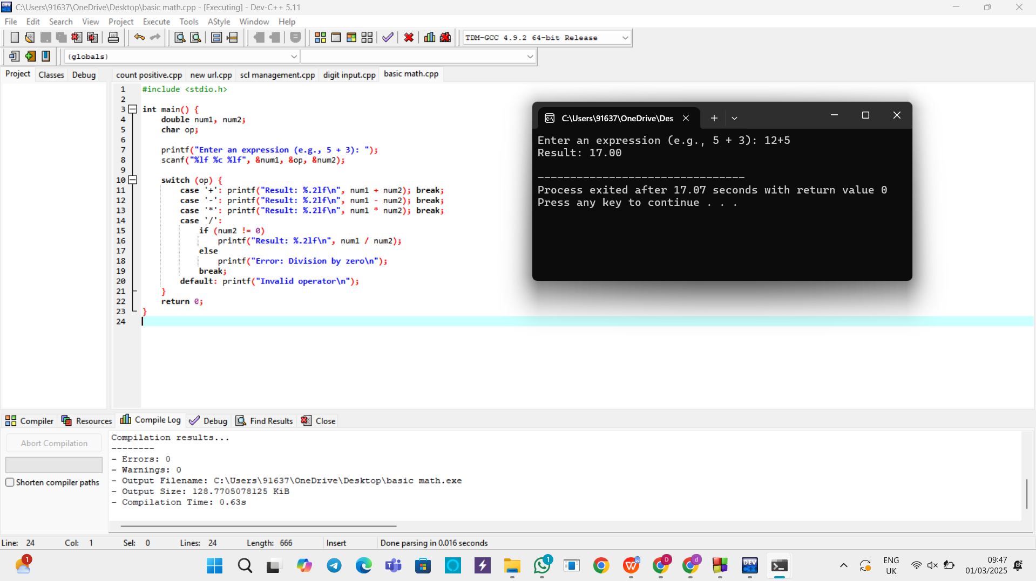

36.Write a LEX program to accept string starting with vowel.

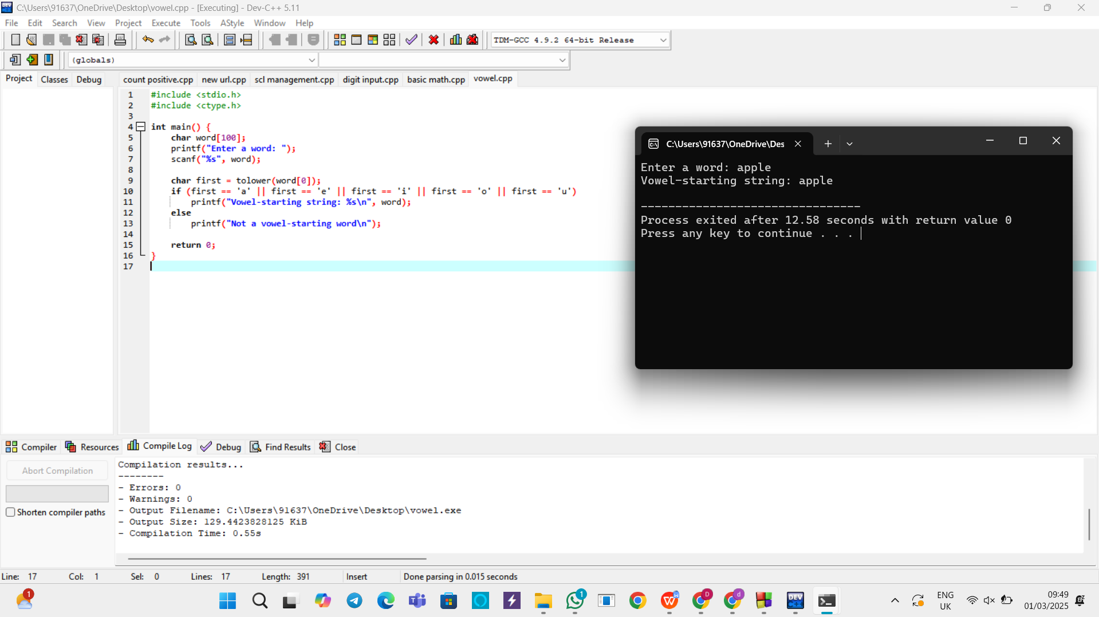

1. Write a LEX program to find the length of the longest word.

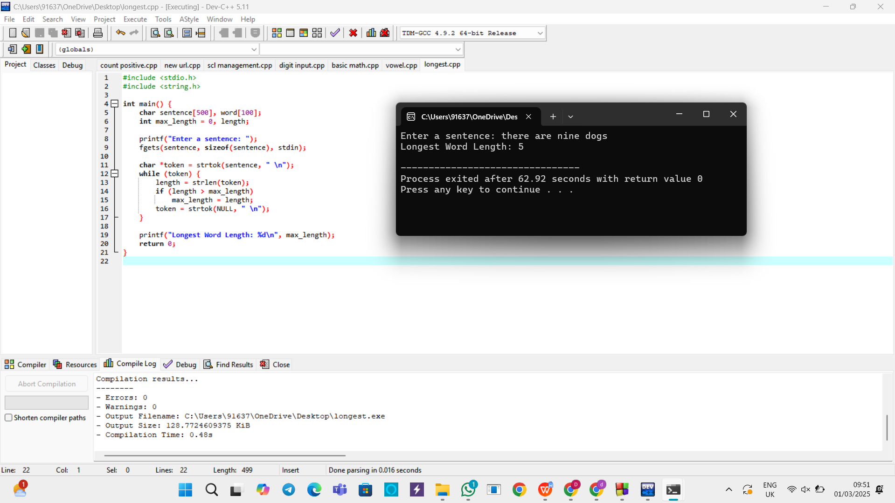

1. Write a LEX program to count the frequency of the given word in a given sentence.

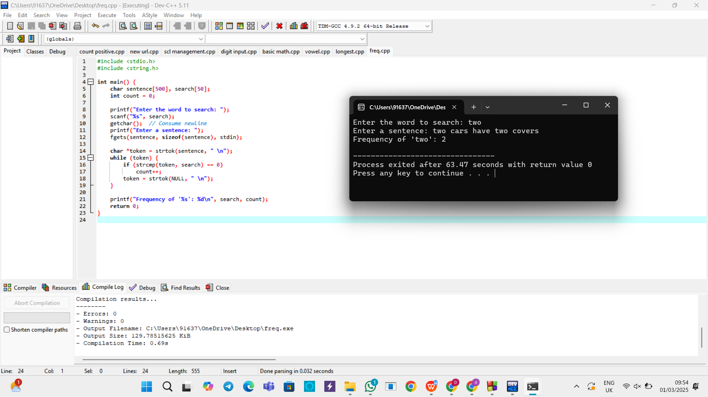

1. Write a LEX code to replace a word with another word in a file.

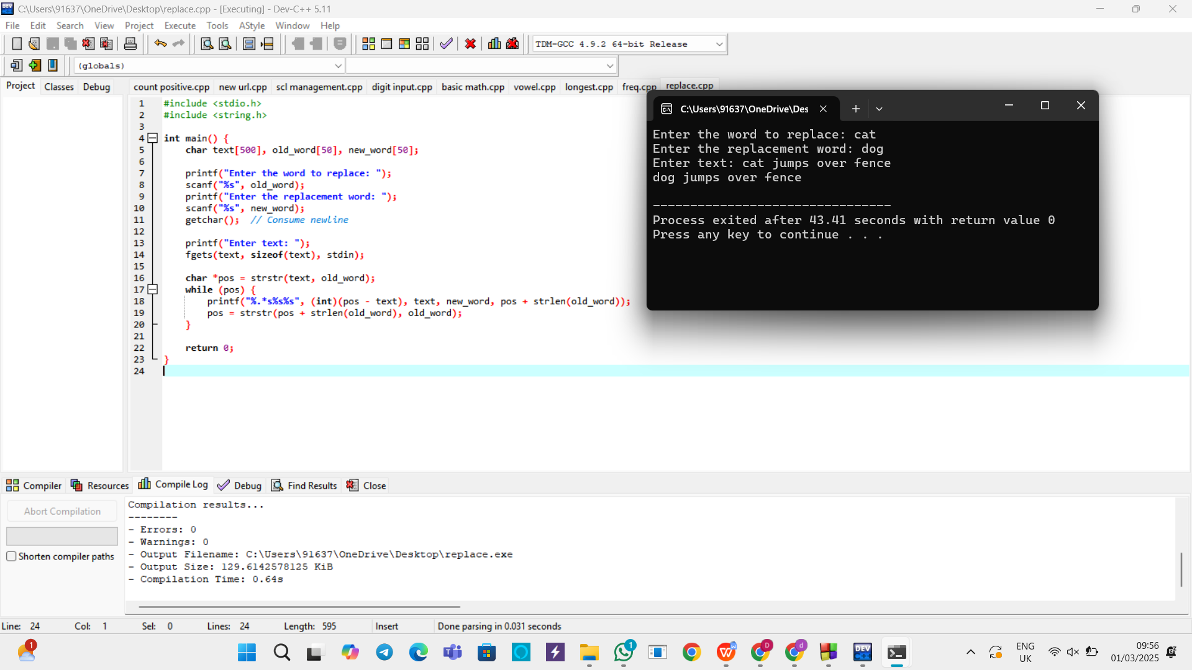

1. Write a LEX program to recognize a word and relational operator.

